Interface Design Description (IDD) – Energy Forecast

**Abstract**

This document defines the template for the Interface Design Description of Arrowhead compliant Interfaces.

An Interface Design Description provides a detailed description of how the service is implemented/realized by using the Communication Profile and the chosen technologies.

All Arrowhead Interface Designs should be specified using this template and stored on a common repository (available on the SVN server), in order to document and formalize the pilot demonstrators and the common Arrowhead framework.

Table of contents

1. Interface Design Description Overview 2

2. Interfaces 3

3. Information Model 3

4. References 3

5. Revision history 4

5.1. Amendments 4

5.2. Quality Assurance 4

1. Interface Design Description Overview

Table 1 Pointers to SD documents

|  |  |
| --- | --- |
| **Service description** | **Path** |
| EnergyForecast | SD Service Description - Energy Forecast.docx |

Table 2 Pointers to CP documents

|  |  |
| --- | --- |
| **Communication Profile** | **Path** |
| REST_WS-TLS-XML | Arrowhead CP REST_WS-TLS-XML v1.0.docx |

Table 3 Pointers to SP documnets

|  |  |
| --- | --- |
| **Semantic Profile** | **Path** |
| EnergyForecast | SP Semantic Profile - Energy Forecast.docx |

1. Interfaces

The service contains a single function, using the REST GET operation to obtain an energy forecast:

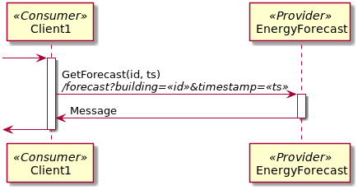

1. Information Model

It returns an energy forecast, containing the amount of energy required for the hour. An example:

{

"entry" : [ {

"outTemp" : 18.5,

"total" : 2.844743,

"water" : 0.19947559,

"timestamp" : 1534752000,

"building" : 1

} ],

"tstart" : 1534752000,

"tend" : 1534752000

}

1. Revision history

# Amendments

|  |  |  |  |  |
| --- | --- | --- | --- | --- |
| No. | Date | Version | Subject of Amendments | Author |
| 1 | 20-9-2017 | 0.1 | First Draft | Thomas Pedersen |
| 2 | 11-12-2017 | 0.2 | Updated, according to Jerker’s comments | Thomas Pedersen |
| 3 | 2018-05-29 | 0.3 | Updated to learning algorithm. | Thomas Pedersen |
| 4 | 2018-08-20 | 0.4 | Updated to Arrowhead 4.0 | Thomas Pedersen |

# Quality Assurance

|  |  |  |  |
| --- | --- | --- | --- |
| No. | Date | Version | Approved by |
| 1 |  |  |  |